CORONA FIGHTER (JAVA,HTML,CSS,JPA FRAMEWORK,JSF FRAMEWORK, ORACLE DATABASE)

PAGE 1***: HOME PAGE***

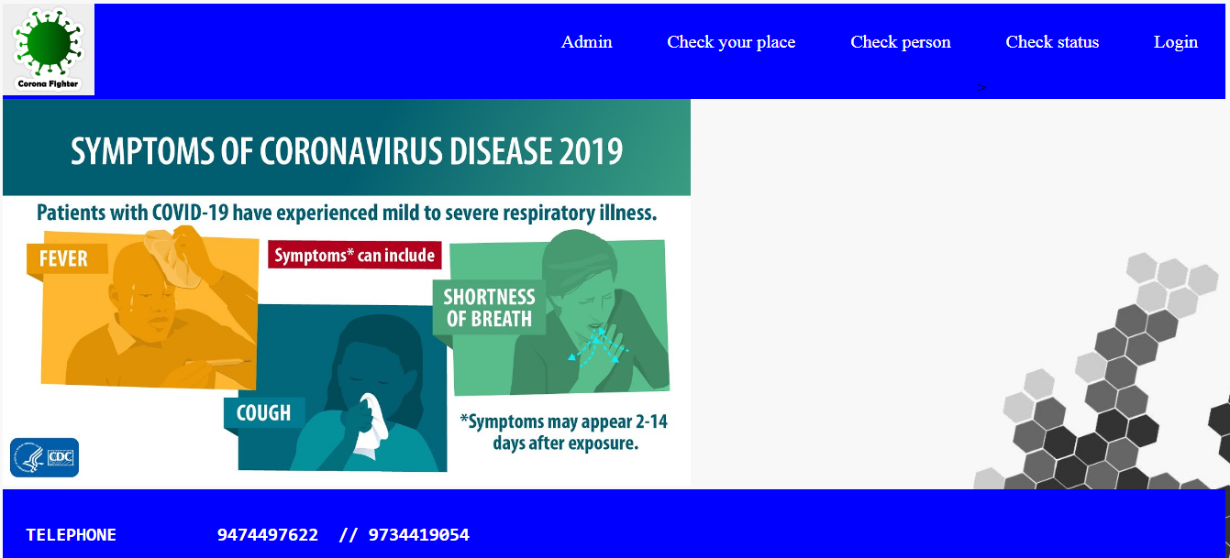

Page 2***: LOGIN PAGE***  Here user can create and check his profile.

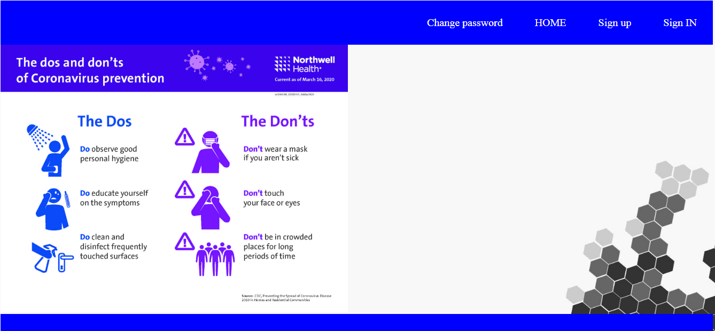

Page 3: ***SIGN UP:***  Here the user can enter his/her personal information such as Name, Mobile number, Location, age etc.

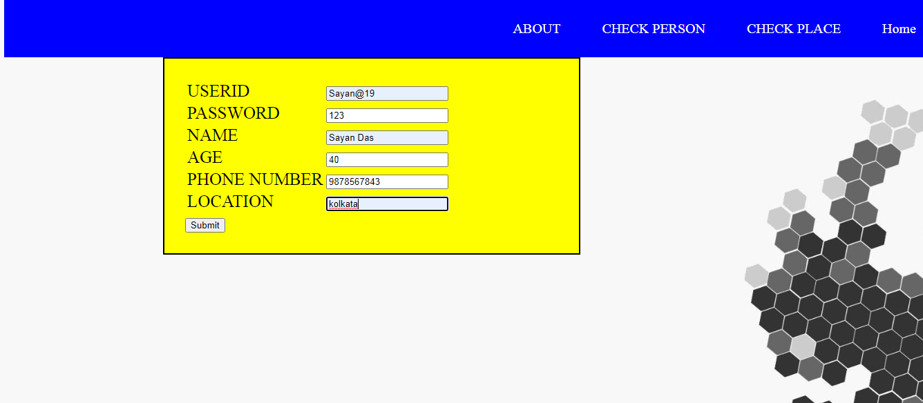

Page 4: ***SIGN IN:*** Here the user can update his profile and enter medical information.

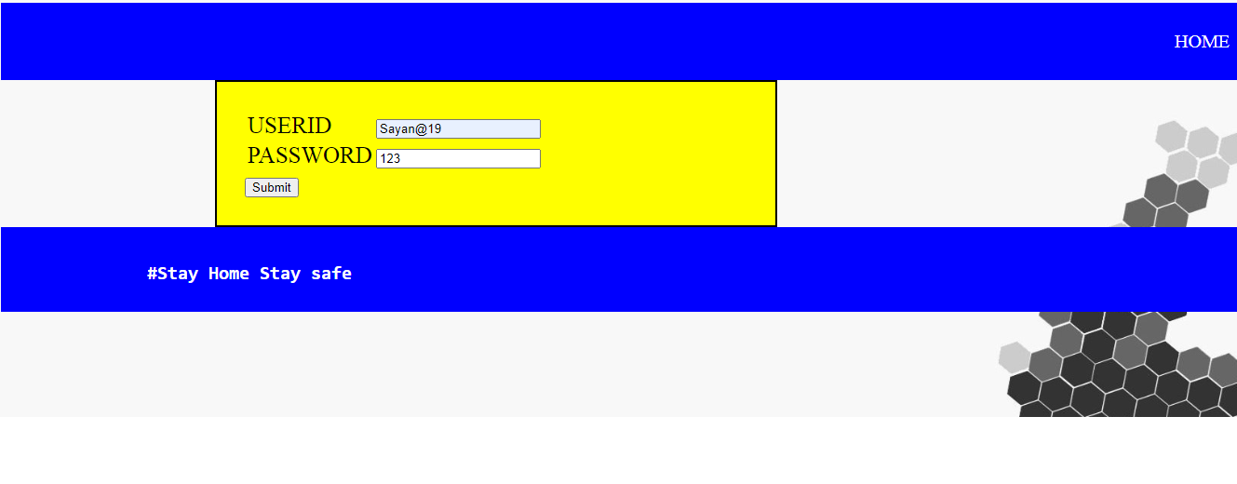

Page 5***: Test page*** This page predict the chance of corona of the user.

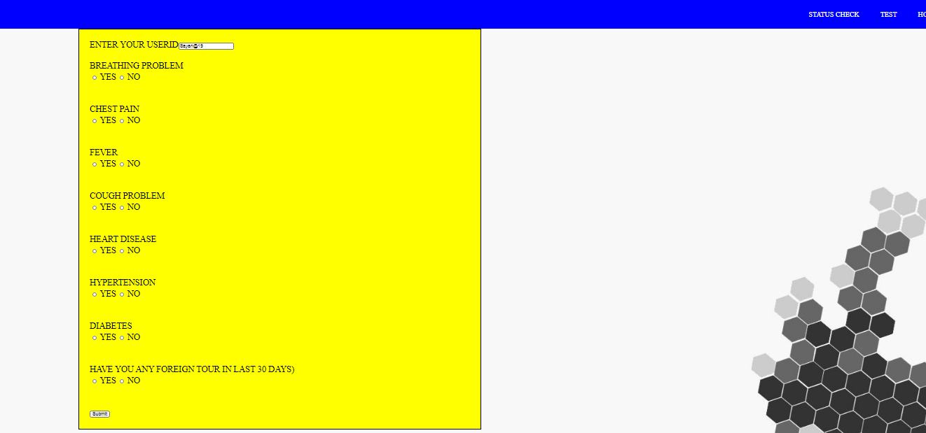

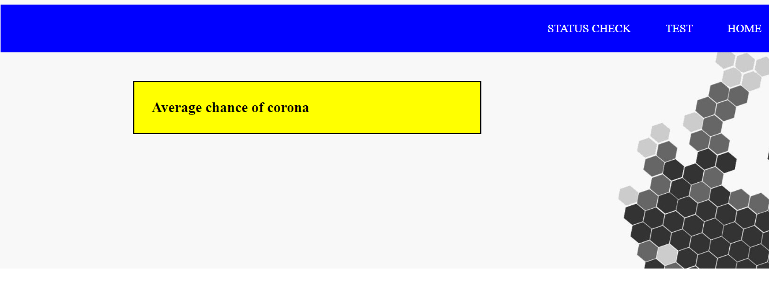

Page 6: ***Check Place page:*** Here user can check the number of cases in a particular area.

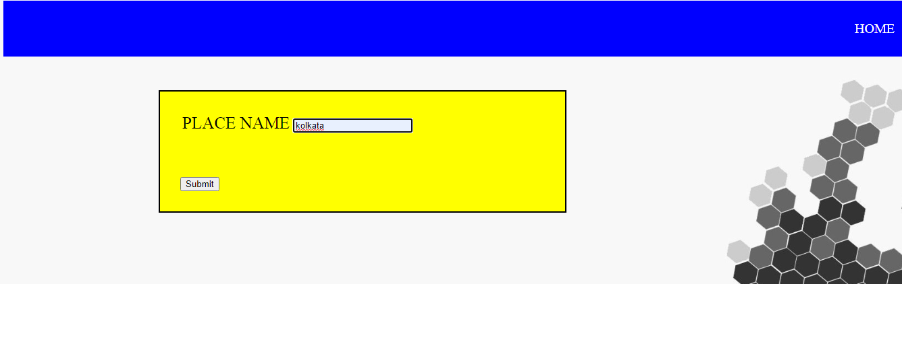

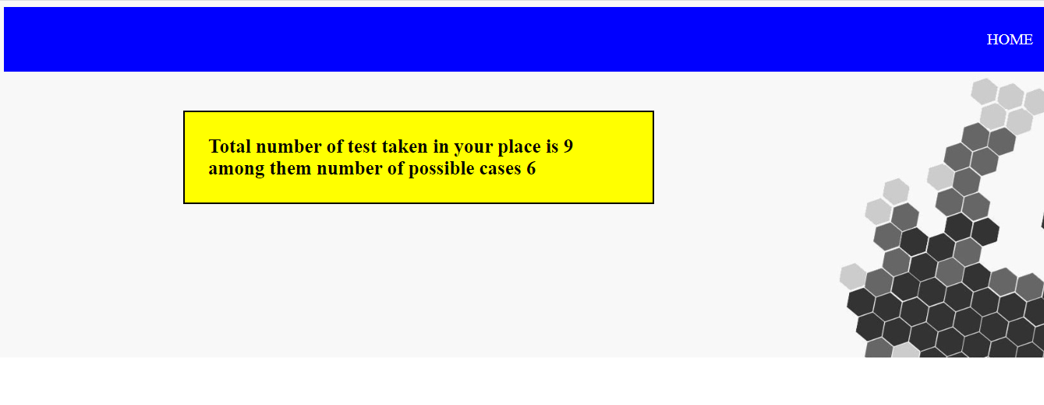

Page 7: ***Admin Page:***  Here the admin can check all the user details



